**Assignment 2:**

Power Management and Power Supply

**Embedded Systems Design**

**MCTE 4342**

**SECTION 1**

**SEM 2 SESSION 2023/2024**

**NAME:** WAN MUHAMMAD RAFIQ BIN WAN MOHD RUSHDAN

**NO MATRIC:** 2011341

**LECTURER:** ASSOC. PROF. DR. ZULKIFLI BIN ZAINAL ABIDIN

# Introduction

Electrical energy is one of the types of energy that are crucial to powering machines nowadays, and the usage keeps increasing every day. Hence, the advancement and discovery of technological advancements in power management and power supply have become demanding in order to cope with the supply and progression of industry and research nowadays. There are a lot of types of power supplies that power up machines, but for mobile technology and backup power, they are mainly supported by electrical energy from batteries. However, the usage of batteries did not last very long due to their limitations in capacity and energy density. Thus, most microcontrollers have some power management to reduce power consumption, either using hardware or software methods.

# Power Supply

1. Fixed Power Supply

* Input voltage: 110-240 AC *Depending on the country.
* Input Frequency: 50-60 Hz
* Output: 5V-24V depending on power usage
* Method: Using the buck (step down) converter to the microcontroller
* Trend: Mobile charger phone adapter as can draw a lot of power in small weight and universal with different types of cable

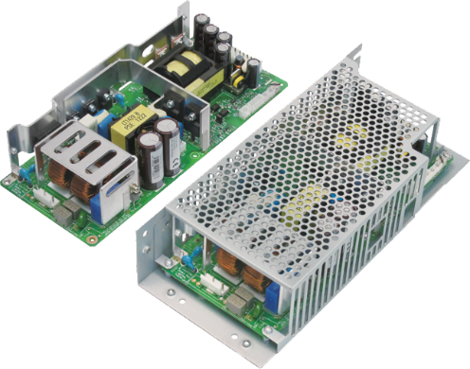 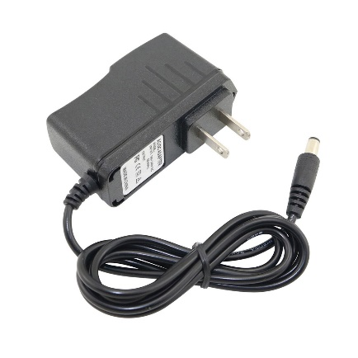 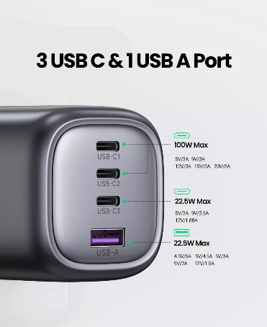

1. Mobile Power Source (Batteries)

|  |  |  |  |
| --- | --- | --- | --- |
| **Battery Type** | **Energy Density (Wh/kg)** | **Advantages** | **Disadvantages** |
| Lithium Polymer (Li-Po)  A Guide to Lithium Polymer Batteries for Drones - Tyto Robotics | 90-160 | - Lighter design - 20% more energy dense than Li-Ion - Safer than Ni-Cd - Higher energy density than Ni-Cd | - Requires essential care (e.g., maintaining voltage) - High cost per unit |
| Lithium Ion (Li-Ion)  4 Pcs ICR 10440 Rechargeable Li-ion Battery, 3.7V Malaysia | Ubuy | ~0.5 | - Commonly used in medical purposes - Twice the specific energy of animal fat - Less fire risk than Li-Po | -Fire risk - Lower energy density compared to Li-Po |
| Nickel-Cadmium (Ni-Cd)  battery: nickel-cadmium battery - Students | Britannica Kids | Homework Help | 40-60 | - Suitable for medical purposes in some regions (e.g., EU) - Voltage of 1.2V - Recyclable | - Memory effect during charging - Toxic heavy metals (e.g., cadmium) - Low energy density compared to Li-Po |
| Nickel Metal Hydride (NiMH)  Nickel Metal Hydride Battery - an overview | ScienceDirect Topics | 65-80 | - Higher specific energy than Ni-Cd - Long life cycle - Initial metal hydride storage anode capacity | - Performance degradation due to temperature rise - Corrosion of electrodes - Lower energy density compared to Li-Po |
| Lead-Acid | 30-40 | - Recyclable - Non-flammable water-based electrolytes - Recycling rates of 99% - Low cost per Wh | - Slow recharge rate - Fast charging requires high voltage - Constant charging of idling batteries - Lowest energy density among others |
| Graphene  Yowoo 3S Lipo Battery 4000mAh 100C 11.1V Graphene Battery Compatible for  1/10 RC Car Truck Truggy Boat Heli Airplane Helicopter Quadcopter FPV Drone  ... | > 400 Wh/kg | -High capacity  -Faster charging  -Light weight ratio  -Flexible with a larger surface area | -Higher cost due to early used in the market  -Low scalability due to low material availability |

# Power Management

1. Hardware Power Management

* Operating System Power Modes: Modern operating systems incorporate power management features such as sleep, hibernate, and standby modes to conserve energy when devices are not in use. These modes allow the system to reduce power consumption by powering down non-essential components.
* Dynamic Voltage and Frequency Scaling (DVFS): DVFS is a software-based technique used to adjust the operating frequency and voltage of a processor dynamically based on workload demands. By scaling down frequency and voltage during periods of low activity, DVFS reduces power consumption while maintaining performance.
* Task Scheduling Optimization: Efficient task scheduling algorithms can optimize the utilization of processor cores, minimizing idle time and reducing overall power consumption. Techniques such as task migration and load balancing help distribute workload evenly across cores.
* Peripheral Management: Software can control the power state of peripheral devices such as USB ports, network interfaces, and display panels. By selectively powering down or placing peripherals into low-power modes when not in use, software can further reduce energy consumption.
* Application Power Profiles: Software applications can implement power profiles that adjust their behavior and resource usage based on power availability and user preferences. For example, mobile apps may reduce screen brightness or disable background synchronization to conserve battery life.

1. Hardware Power Management

* Low-Power Components: Hardware components designed with low-power consumption in mind, such as low-power CPUs, GPUs, and memory modules, contribute to overall energy efficiency in computing devices.
* Power Gating: Power gating involves selectively shutting off power to specific blocks or components within a chip when they are not in use. This technique reduces static power consumption and leakage currents, particularly in idle or low-load scenarios.
* Clock Gating: Clock gating is a hardware technique that involves dynamically disabling clock signals to unused logic blocks or functional units within a processor or system-on-chip (SoC). By halting the clock to idle components, clock gating reduces dynamic power consumption.
* Dynamic Power Management (DPM): DPM techniques adjust voltage and frequency levels dynamically based on workload demands and performance requirements. These techniques optimize power consumption while maintaining system responsiveness and performance efficiency.
* Temperature and Thermal Management: Hardware-based thermal management systems monitor the temperature of components and adjust operating parameters such as clock speed and voltage to prevent overheating. Thermal throttling and fan control mechanisms help maintain safe operating temperatures while minimizing power consumption.

# Conclusion

In conclusion, the power consumption of the microcontroller needs to be improved with to cope with the needs of energy to power up all the machines nowadays with limited resources. Hence, the engineers need to explore and enhance the research in power management to maximize the efficiency and capacity of batteries so it can last long and more cheaper to the consumer.